# Operations Program

During this quarter, the LHC was shut down (Long Shutdown 1, LS1). CMS has been engaged in a variety of activities during the shutdown that are described in the subsystem sections below.

## Milestone Status

Table 1 shows this year’s milestones. Milestones with dates in green were achieved this quarter. The PLT plan was impacted by the previously reported problems with the pixel system that resulted in a change in the work plan. This milestone was ultimately met in Jan. 2015. The tracker group reported in the previous quarterly report. A modified version of the tracker milestone was also met in the New Year. The strips and pixels were operated at – 15C in the lab. A decision was made to operate the pixels at – 10C due to issues with humidity in the BPIX that were identified during the investigation of the problems described last quarter.

Table 1: Milestones for 2014.

|  |  |  |  |
| --- | --- | --- | --- |
| **System** | **Description** | **Scheduled** | **Achieved** |
| HF PMT | HF-ROBOX refurbishment completed | Oct-13 | Jan-14 |
| ECAL | New laser installed and working at P5 | Nov-13 | Mar-14 |
| Trigger | Develop CSCTF firmware, LUTs for new ME4/2, ME1/1 | Dec-13 | Apr-14 |
| ME1/1 | Plus endcap chambers commissioned | Mar-14 | Mar-14 |
| Trigger | Integrate unganged ME1/1 into CSCTF firmware | Apr-14 | Apr-14 |
| Trigger | Test 5 upgraded Muon Port Cards w/legacy trigger | Apr-14 | Apr-14 |
| ECAL | Finish recabling ECAL electronics | May-14 | May-14 |
| ME1/1 | Minus endcap chambers reinstalled | May-14 | Mar-14 |
| ME4/2 | Minus endcap installed | May-14 | Mar-14 |
| HO PMT | Silicon PMs installation complete | Jun-14 | Apr-14 |
| HF PMT | HF ROBOXs installation complete | Jul-14 | Mar-14 |
| DAQ | DAQ2 commissioned | Jul-14 | Jul-14 |
| Trigger | Operate full legacy calorimeter trigger in global run | Jul-14 | Oct-14 |
| TRK | Forward Pixel ready for installation | Jul-14 | Aug – 14 |
| BRIL | PLT ready for installation | Aug-14 |  |
| TRK | Tracker Detector certified for operations at -20C | Dec-14 |  |

# Tracker

## Pixels

Final preparations prior to insertion were completed. All channels were rechecked for functionality after the pilot upgrade detector was installed in two half disks. One minor connection problem was fixed. All cooling loops were run prior to the insertion to check for flow problems. No flow problems were seen. The pixel online software was tested again on scientific linux version 6 with a new vme controller and no issues were seen. For the installation of the pixel detector, the new mounting brackets for the service cables were used and the installation progressed on schedule, followed by the check for functionality. The barrel pixels (BPiX) were installed in CMS on Dec 8-9, 2014, and the forward pixels (FPiX) were in CMS installed on Dec 13-15, 2014. Initial checkout of both the BPiX and the FPiX was completed on Dec 18, 2014. For the BPiX, it looks like one additional module may have unrecoverable problems. For the FPiX, it was a clean sweep: no new problems were encountered after installation, and FPiX is more than 99.9% operational. The Long Shutdown One (LS1) program of channel recoveries, improving software, and training new personnel has had its initial good return on investment. Calibration of the detector at -10C will start after the break and continue until the installation of the luminosity detectors around Jan. 20th.

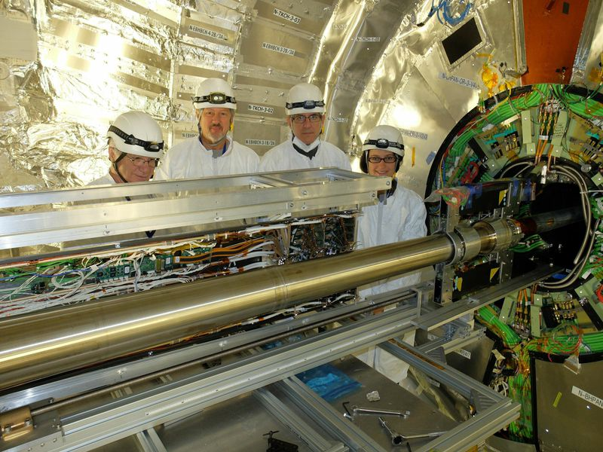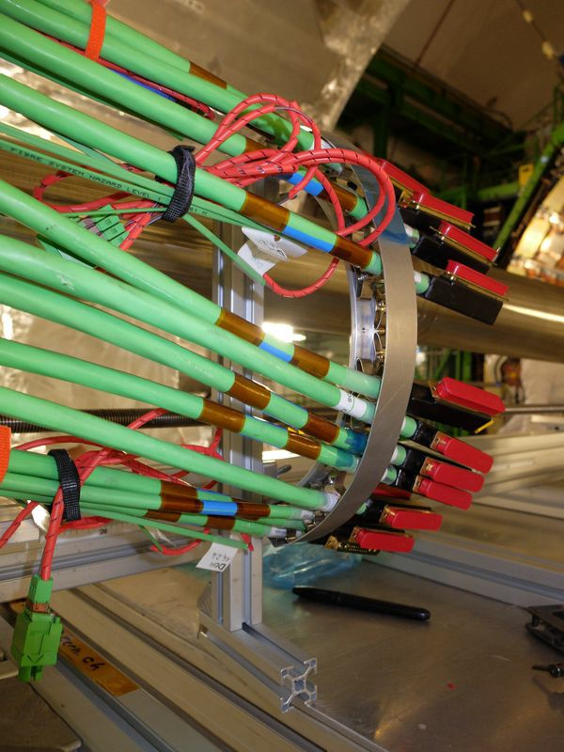

Fig. 2: Detail of new cable bracing tool made for the pixel re-installation this year. Previously, the bracing was uneven and improvised.

Fig 1:The installation crew with the first half cylinder on the scissors table. Left to right: Pasquale D’Angelo (Vanderbilt), John Thompson, Jon Conway and Rachel Yohay (all UC Davis).

## Strips

Strips participated in the muon cosmic running this fall with magnet on and off while operating at lower temperatures. Several DAQ problems were addressed (including a spurious reset issue that was a little challenging to fix). Analysis of cosmic running is ongoing. At present, we are looking for ways to increase the useful data we take so alignment with cosmics will be more efficient after the break. With the lower temperatures in the tracker volume and cooling infrastructure, it was found that some pneumatic control lines were becoming clogged with ice. Since the control lines operate at higher pressure, residual humidity is more of a problem. We are trying to get the control lines operated from a drier source, moving control lines away from cold surfaces, and adding monitoring to the control air. The combined Digital Control System (DCS) for strips and pixels was used successfully for the pixel checkout and for strip operations. Further testing will be done, and the transition to the new PSX server (allows communication between the DCS and the DAQ) will be completed after the break. Work continues on maintenance of the power system with firmware upgrades being done, faulty modules being replaced, and testing of safety and reset systems. The tracker was shut off for the pixel installation and will be turned back on after the break. The sealing of the tracker volume for the break resulted in very stable dew points (typically -30C or below), which bodes well for operations after the break.

# Pixel Luminosity Telescope/BRIL

The main emphasis of the US-CMS effort as part of the BRIL sub-detector group is the pixel luminosity telescope (PLT) that was originally scheduled for installation by end of August, but is now scheduled for January 20th. The PLT is assembled on the same carriage as the slow and fast beam condition monitor detectors. The PLT was assembled completely and tested in dry boxes simulating the environment inside CMS with the temperature kept at -15 degrees Celsius. Running calibrations and noise readout continuously tests the detectors. For this we acquired a chiller for BRIL shared with and co-financed by the cooling group at CERN. The carriage holding PLT and BCM detectors with the cooling infrastructure was finished in December and all parts are ready to be transported to P5 for final installation in January. While switched off during the CERN winter break operations will be resumed January 5th. The HV supplies and the FE modules and online computers are installed in racks in the P5 support cavern. As for spare parts and long term operations: we have now right-side and left-side spare port cards, and spare HDIs. Further production of spare HDIs is under discussion.

The PLT served as prototype for the development of a global beam radiation and luminosity data acquisition system (BRILdaq) based on XDAQ to integrate all subsystems of BRIL. We have been responsible for constructing a module to broadcast both unprocessed and processed lumi information as well as event-by-event data through a new service provided by XDAQ. This software framework is in place and the modules for the PLT have been finalized and stress tested. The online operation software (user interface, data quality monitoring) has been installed after migration of the operation system on the online computing systems to Scientific Linux 6.

A detailed installation schedule has been developed. As soon as a carriage is in place and linked to the readout we are able to test the detectors; in case of problems diagnostics is in place locally and if necessary in the laboratory at the TIF - a prioritized action list is in place. The total time allocated for installation is one week (plus 3 days contingency). On November 25th BRIL underwent and passed an installation review by the technical coordination of CMS. The personnel to install and commission the detector from participating US institutes Princeton, Rutgers, Tennessee, Vanderbilt, and Wisconsin has been identified.

# Electromagnetic Calorimeter

The recent series of CMS Global Runs were used to check the status of the ECAL barrel, endcap and preshower detectors and to commission new systems in readiness for Run II. Significant development work was carried out to adapt the ECAL online software to the new central data acquisition framework (DAQ2) and to the new trigger control and clock distribution system (TCDS). The ECAL calibration sequence was successfully commissioned using the TCDS framework. A measurement of the transparency of EB and EE crystals was obtained during the 3.8T magnet test in early November, and this was used to track the continued recovery of crystal transparency during LS1.

A crucial milestone in the commissioning phase of the optical Synchro-Link Boards (oSLB) and optical Receiver Modules (oRM) was also achieved during these runs. These modules split the ECAL trigger primitive output and transmit the trigger data to both the existing and the upgraded Level 1 trigger systems. This will facilitate the simultaneous operation of both systems in 2015. All required oSLBs and oRMs were installed during the Summer, together with the necessary optical fibres. The full chain was tested using the global runs, marking the successful completion of this project.

In the Detector Performance Group (DPG), work has focused on optimizing the ECAL local reconstruction for collisions with 25ns bunch spacing. A substantial improvement in the mitigation of out-of-time pileup has been achieved with a new energy reconstruction algorithm. This approach (termed the “multi-fit” method, illustrated below) involves fitting up to ten pulse shape templates (shifted by multiples of 25ns) to estimate and subtract the contribution from overlapping out-of-time energy deposits. Indications from Monte Carlo simulations show improved energy resolution for electrons and photons (especially at low pT) as well as a significant reduction in the sensitivity to out-of-time pileup compared to the Run I algorithm. This method, which is proposed for use both online (at the HLT) and offline, will be thoroughly validated with data and simulation in the coming months prior to its deployment in Run II.

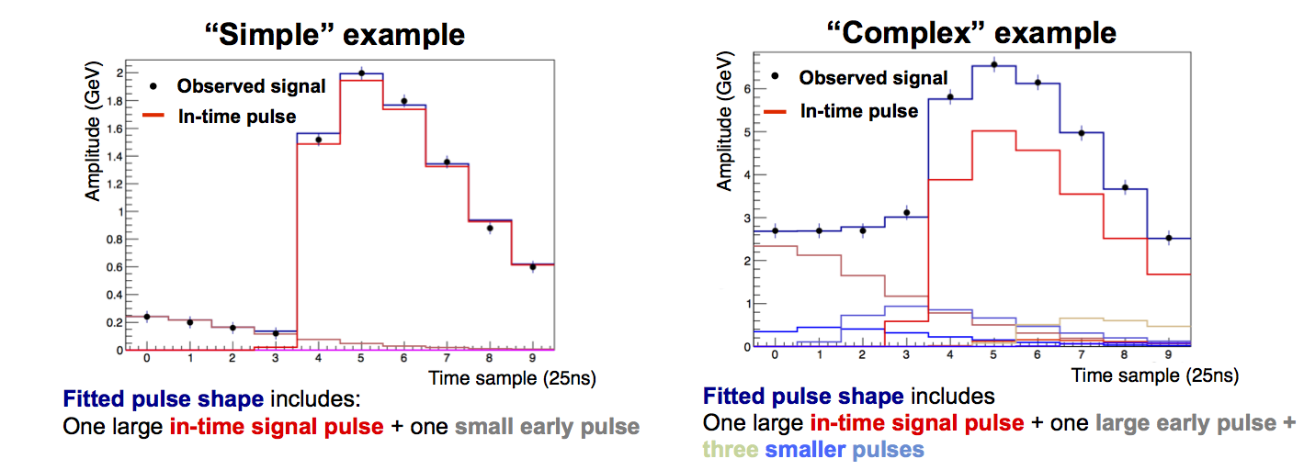

Fig. 3: Simulated ECAL pulse shapes from collisions with 25ns bunch spacing showing the concept of the “multi-fit” algorithm.

The ECAL Calibration group is optimizing its selection algorithms to maximize the rates of useful calibration events in Run II. We plan to maintain the possibility to perform regular calibration with W→e events in Run II by implementing a dedicated single electron calibration stream with reduced event content. In parallel, work is ongoing (in conjunction with the TSG) to achieve the lowest possible Level-1 single electron threshold in 2015, which is crucial to maximize the selection of W→e events for calibration purposes.

# Hadronic Calorimeter

The improvements to the HCAL planned for Long Shutdown 1 (LS1) were largely completed in previous quarters. In this quarter the main activities were finishing the few remaining improvements and commissioning and calibrating the HCAL in preparation for Run 2. This included offline software and analysis activities to prepare for 25 ns running and for the challenges of radiation damage.

For the HF, the multi-anode phototubes have been installed on both sides of the detector. The new phototubes have thin glass windows, which will result in less background from Cerenkov radiation from particles traversing the glass. The CO-60 source data collected in summer 2104 has been analyzed and an initial set of calibrations extracted. Simulation studies of HF timing are underway. However, precision re-timing of the HF will require beam. The new HF back-end readout crates based on the MicroTCA industrial standard are being installed. Two thirds of the crates are already fully populated and can be read-out. The last set of electronics cards for the new crates should be installed in January. There was delay due to some of the cards being damaged during shipment from India and having to be repaired.

The new silicon photomultiplier (SiPM) replacements for the HO photo-detectors were installed in April. The HO participated fully in 2014 cosmic global runs with the new readout. The HO muon efficiency using muon-system triggered events was shown to be very high (~95%). In addition, in was demonstrated that the HO can be calibrated at startup using MIP signals from cosmic muons.

For the HB and HE, various new electronics components (notably new Clock and Control modules) have been installed and tested. These should prevent the single event upsets observed in Run 1, and permit the HB and He readout system to lock at the LHC frequency reliably during 25 ns running.

A new XeF excimer laser has been installed and adapted to the existing optics. Much better performance (2 ns timing, larger signal) has been measured. The new laser system is currently being integrated into the HCAL global and local DAQ.

The Prompt Feedback Group has been re-established and is working on verifying HCAL performance in cosmic global runs, debugging problems with HCAL data, analyzing the local calibration runs (laser, LED), and developing tools for certifying global run data.

The Detector Performance Group has concentrated on preparing for HCAL calibration in 2015, improved handling of the HCAL L1 trigger, and adaptation of the energy reconstruction and noise filtering algorithms for 25 ns running. Software and a detailed plan for calibrating the detector with beam exists, and two algorithms for HCAL signal reconstruction during 25 ns running have been implemented and are being tested. HCAL radiation damage has been incorporated in the HCAL Monte Carlo and improved agreement between simulation and data (particularly for HCAL L1 triggers) has been obtained.

# Endcap Muon System

Cosmic Runs and System Commissioning

The series of global runs of cosmic ray data began in Summer 2014 continued in the Fall. The series included an Extended Cosmic Run (ECR) that took place from 27 October to 12 November. Figure 4 shows the occupancy of the CSC chambers in one of the ECR runs. All chambers are included in the run, and the distributions are characteristic of the cosmic rays (triggered by the bottom detectors), with very few examples of excesses or deficits from hardware problems. Several aspects of the muon DAQ and triggering were tested in the global runs, including high rate stress tests, and synchronization with the trigger system.



Figure 4: Occupancy plots for CSC chambers for Run 228593 of the Extended Cosmic Run. Events were triggered on the bottom half of the detector.

One of the features observed is some noise induced in particular chambers by the RPC system identified in some discharging HV connections. Investigation continues on this. In addition, there were two operational problems observed that were particular to the ME1/1 system. In one of these, an OTMB module can get into a state where it does not respond to ordinary VME commands. A successful way to reset was developed, but the origin of the problem is not yet known because it is rare and difficult to reproduce. The second problem involves the optical data transmission between the DCFEBs and the OTMBs. This is sometimes seen to be corrupted in such a way that the comparators appear to be giving an excessive hit rate. New OTMB firmware was deployed that provides monitoring of the status of each optical link. The suspected cause of the problem was found in the start-up sequence of the FPGA on the DCFEB, and new firmware was deployed in December to correct this problem.

## Magnet test

The solenoid was ramped up to 3.8 T on 11 November and back down to 0 T on 13 November. The CSC electronics were continuously exercised during the ramp up and the plateau, and the system worked normally. There were individual chambers that displayed problems resulting from the field. A few ME4/2 chambers had HV trips during the ramp; these will be cured with reverse polarity training and adjustment of trip thresholds. One chamber (ME-1/1/02) lost communication with the ALCT when the field reached 1 T. This chamber was subsequently extracted, and it was found that one of the cables to the ALCT had become partially dislodged from the connector. It is suspected that this was a consequence of the movement of the end cap with the magnetic field. The ALCT board and the cables going to it were replaced. The chambers was reinstalled in December, and the post-installation electronics tests were successful.

YE3-YE4 push-back system

A new interference was uncovered while installing the remaining parts of the push-back system between the jack supports and some CSC cooling valves at the bottom of the YE3 disk. The conflict will require inserting 90 degree elbows to turn the valves away from the supports. Re-machining of the supports has not been considered effective from CMS Technical coordination even though the issue should have been detected at the support design stage when there would have been time to correct for it. New parts have been ordered in US and delivered to CERN before the holiday closure. The intervention is scheduled for early this year.

Cooling and gas system

Additional fans were added to one LV power converter rack that had been running at a marginally high temperature of 47 C.

Starting on 23 October, the CF4 recuperated from the system in Run 1 was re-injected into the CSC system in order to reduce costs and environmental impact. No ill effects have been seen from using the recuperated gas. The new gas monitoring system on the input and exit of the gas circuit, comprised of 55Fe sources and proportional counters, was put into operation. It provides prompt feedback and complements the information from the gas chromatograph.

In November, the gas flow was increased to ME4/2, and the oxygen contamination was reduced to levels comparable with other chambers.

Timing Parameters

The new Timing Task Force (TTF2) continued to be very active in studying the timing of the CSC system and developing tools for setting timing parameters. After completion of the online anode timing (ALCT) last quarter, new software was developed to time in the cathode local triggers (CLCT) in ME1/1. The relative timing of the different stations was adjusted to give consistent values for the beam crossing. Also, the system was timed in with respect to the DTs and the RPCs. There is an additional parameter that must be tuned to get the peak of the cathode charge signal timed in correctly. Once this is done, the setting of the online timing parameters will be essentially complete until they can be tested with beam data. Work continues on the offline timing parameters.

Online Systems

Following the migration to new computers running SLC6, several issues were encountered. The network switch gave problems with broadcast of commands to multiple crates. The root cause of this interference is still under investigation, and a packet-sniffer was used to collect data about packet losses. Meanwhile, a work-around solution was found which requires disconnecting some network interfaces. A problem was discovered which caused the monitoring of the CSC Track Finder to be very slow. The SX5 test stand was revived and the software updated in order to facilitate the testing of extracted chamber ME-1/1/02. The FED crate software was updated to add SLINK IDs, and it was ported to XDAQ 12 and tested.

## Preparation for higher luminosity operations

New firmware was deployed in the DCFEBs in the ME1/1 system which incorporates several features to deal with Single Event Upsets (SEUs) that could arise from radiation effects. The firmware employs detection of SEUs and scrubbing of the configuration memory, plus Triple Module Redundancy (TMR) for all of the critical logic.

In preparation for possible future construction of DCFEBs for ME2/1, ME3/1, and ME4/1, the layout files for the comparator ASICs were recovered and it was verified that a suitable 2.2 µm production process is still available.

Offline Software and DPG

An analysis of the data from the Extended Cosmic Run was presented at the CMS cosmic data jamboree in December. The data with 3.8 T were compared with those from 0 T and with cosmic data from 2012. The new ME4/2 CSCs behaved the same as the five ME4/2 CSCs that were installed in Run 1. The positions from the unganged ME1/1a cathode strips behaved better than in 2012 when they were still ganged, with narrower pedestal distributions and no ghost segments. As expected, there were no difference seen in performance in the 3.8 T data with respect to the 0 T data. Chamber position resolution were extracted for all chamber rings and compared to previous Run 1 cosmic ray data at 3.8T. The results generally show improvement, and are more uniform among the rings than in the previous cosmic data.

## CSC Organization

With the ME4/2 and ME1/1 projects installed and LS1 coming to an end, the organization of the CSC within international CMS was revisited. EPR needs for 2015 were defined (375 FTE-months, down from 451 FTE-months in 2014) and the CSC internal group organization was revised to emphasize running, maintenance and preparation for upgrades beyond LS1.

## CERN end-of-year shutdown

The CSC system was turned off on 18 December to prepare for the end of the year shutdown at CERN. The cooling and safety monitoring remained active. The gas system was switched over to the backup dry gas supply. About three days of circulation with regular chamber gas will be required in January before the chambers can be operated again.

# Trigger

## Calorimeter Trigger

Since 2007 the 19 crates, 330 9U-VME and 1000 Mezzanine cards of the Regional Calorimeter Trigger (RCT) electronics (covering barrel, endcap, and forward calorimeters) have operated in the CMS underground electronics cavern adjacent to the CMS experiment. It was built and installed by the University of Wisconsin – Madison. Currently the calorimeter is being upgraded to improve performance in LHC Run 2.

Underground in USC55, 18 oRSCs have been installed in the RCT crates, connected to the clock and control signals, the RCT Jet Summary Card ECL output, and the fibers routed to the new legacy patch panels in the lower level of USC55. The optical fibers from the patch panel of the GCT have been detached from the GCT Main Crate and fibers connected from the oRSC legacy patch panels so the route from RCT-GCT was re-established. Final checks were done to verify all of the connections, and after some adjustment of the order of trigger subsystem configuration in the Trigger Supervisor, the calorimeter trigger with the oRSCs to GCT took part in MWGR #9 (8-12 December). Since the latency of the oRSCs was slightly longer, the trigger had to be timed in again.

Since the HCAL is in time with the muon subsystems, one of the first tests was to fire the HCAL LEDs during physics and enable a high-threshold jet trigger. This provided an estimate of the shift of the trigger timing (later by ~4 BX), which was verified with the ECAL TCC patterns and then removed from to the GT calorimeter trigger delay. After this, another set of runs with ECAL patterns verified a 2 BX difference in the GCT readout, and this was corrected to align the readout.

After configuring with the new timing, a new HCAL LED run was made which produced strange emulation results (Figure 1), some good, most bad. It was hoped to repeat HCAL runs, but time ran short. A set of ECAL Test Pulser runs were done, using different super modules, enabling the SingleEG30 trigger, and firing the Test Pulser outside of the gap. Results were not consistent. Plots from two of these runs (Figure 5, from ECAL DPG) show the position of the ECAL pulse shapes in different runs. Results consistent with this shift of 8-9 BX are also seen in the Global Trigger Front End (not shown). After turning back on the system in 2015, the main effort will be to understand if these are due an issue in the RCT-oRSC-GCT system or elsewhere by attempting to isolate the issue.

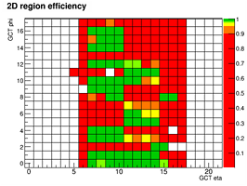 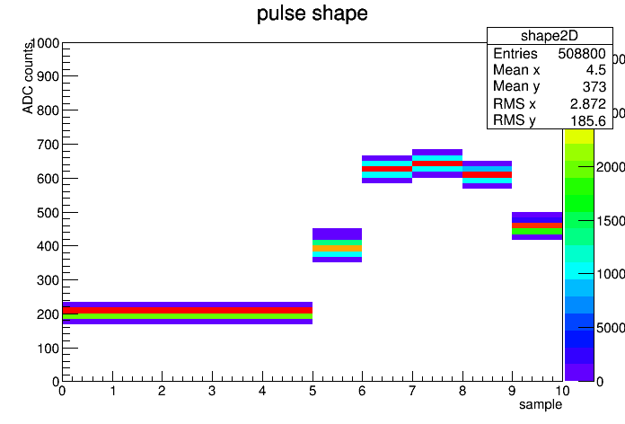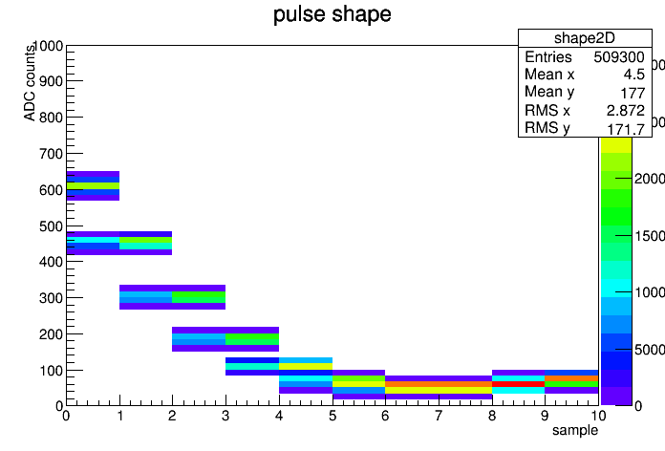

**Figure 5: Left Plot: Emulation of RCT regions during a run (231419) taken with HCAL LEDs (good areas are green). Right two plots: ECAL pulse shape for two runs (231501 and 231507) showing the expected + 2 BX shift in the first plot and an offset of 8-9 BX from that in the second.**

## CSC Muon Trigger

The CSC Trigger is comprised of 60 EMU peripheral crates on the endcap disks housing Trigger Motherboards and Muon Port Cards and a single Track-Finder crate in USC55 housing 12 Sector Processors, 1 Muon Sorter, and a Clock and Control Board. The system was produced by the University of Florida, Rice University, and UCLA.

For the Muon Port Card activity, all 60 upgraded Muon Port Cards have participated in two mid-week and one extended cosmic runs at CMS. Old optical links operated as expected. One exception was a link to Trigger Motherboard responsible for the CSC chamber ME-4/2/1: its half-strip and wire group numbers exceeded expected values in the trigger path from the TMB through the MPC to CSC Track Finder. After visual inspection some bent pins were found in the TMB slot; no errors in data transmission observed after fixing them. Note that this slot has never been used in Run 1. New optical links from two Muon Port Cards in crates -1/3 and -1/6 were dark (no light in any fiber). These two boards were replaced at p.5 and will be shipped to Rice for repair in January 2015.

A test stand comprising two crates is being upgraded at Rice (Figures 6-7). The first is a VME crate with the Muon Port Card, Clock and Control Board, TTC modules and CAEN crate controller. The second uTCA crate includes the MTF7 processor (instead of the previous generation MTF6 board), AMC13 clock and control board and a MCH controller. The goal is to be able to run various data transmission tests and validate new firmware and software.



Fig.6: Block Diagram of the test stand at Rice



Fig.7: Picture of the test stand

A new connection between the CSCTF Clock and Control Board and a TCDS receiver card was validated for local triggering at the CSC system. It has replaced the older CSCTF CCB-to-LTC link.

On the CSC Track-Finder work by the U. Florida group, the online software for the CSCTF has now migrated to XDAQ12, after first upgrading the control PC to the SLC6 operating system, as recommended by the TriDAS project. There is a subtle clash in the monitoring software for the DAQ readout board with our trigger software that is under investigation.

Analysis of the cosmic muon data recorded by the CSC Track-Finder during commissioning exercises has been useful to identify and diagnose specific faults in the electronics for a couple CSCs out of more than 500 (<1%), where some form of data corruption is occurring. This data corruption has been isolated to the CSC peripheral crate electronics and is unlikely to be in the communication path to the CSC Track-Finder. Bent pins were found in one CSC peripheral crate, which when fixed recovered one CSC. Problems with two other CSCs are still under investigation by the CSC group.

Another major activity that took place during this quarter was the refinement of the time synchronization of the signals coming from CSCs and DTs to the CSC Track-Finder. The CSC detector project constructed and installed entire new rings of CSCs in each endcap (ME4/2 chambers) and installed new electronics for the innermost ring of the first endcap disks (ME1/1) to add more electronic channels. We supported the CSC group to synchronize these chambers by providing feedback from our trigger timing analysis. We also timed in signals from the DT muon system sent via the DT Track-Finder for the region of overlap with the barrel, and adjusted delays for the CSC signals sent to the DT Track-Finder. These two systems are now roughly synchronized for cosmic rays.

# DAQ

The U.S. CMS effort in the CMS central DAQ system is concentrated in several areas: the event builder and data to surface hardware, the filter farm running the higher level trigger software and the storage manager which stores the data locally, serves them to the online Data Quality Monitoring system, and ships them to the Tier-0 for reconstruction and analysis and Run Control of all DAQ components. Effort in all of these areas is continuing during LS1 for the upgraded DAQ, known as DAQ2.

DAQ2 system and the new Trigger Control and Distribution System (TCDS) that was read out through the SLinkExpress fiber link of the FEROL module system was successfully used in Midweek Global Runs (MWGR) through out the first quarter of FY 2015 in its basic functionality. The focus during this quarter was on commissioning the DAQ2 system to handle edge cases, improving it's the monitoring and performance and removing some of the short cuts that was necessary to get the system going in absence of some external services. A major milestone to replace the old Storage Manager Disk system was met just in time for MWGR 9.

### DAQ2 system installation and testing

Hardware Infrastructure: At the end of last quarter, all FEDBuilder networks were in place to read out all legacy FEDs and new uTCA based FEDs and full Event Builder network based on Infiniband was commissioned. During FY15Q1, an additional layer of FED Builder switches was ordered to provide full connectivity between all FEDs and all Readout Units (RU). Delivery of these switches is expected by second half January 2015.

One rack of the old Storage Manager (SM) system was converted to run Lustre file system to allow usage of the DAQ2 in MWGRs while investigation on its replacement was on going. The second rack was kept in old SM configuration partly due to lack of network hardware. At the end of last quarter, this old system was showing signs of ailing. In order not to jeopardize the Cosmic Runs At Full Magnet (CRAFT), the second rack was also converted to Lustre file system in emergency by recuperating network cards from BU appliances, to make the file system more robust against hardware failures.

New Storage Manager disk system and Lustre File system was delivered and commissioned just in time for MWGR9 that took place in second week of December. Performance optimization will be carried out during January. Figure 1 shows the layout of the new Storage Manager. It has two disk arrays and extensions – Object Storage Target (OST). Each holds 60 2 TB disk drives, 320 TB of which is available for data storage. OSTs are organized in 10 RAID6 volumes. Each controller and disk array is located in a different rack. 2 DELL PowerEdge R720 hosts serving as Object Store Servers (OSS) are directly connected to each controller. They work in active-active failover mode and both could export the full volume to external clients. Meta Data Targets (MDT) has 16 drives of 1 TB organized as one volume and 8 hot spares. 2 DELL PowerEdge R720 hosts serve as Meta Data Servers (MDS) in active-passive mode. All servers are connected to the 2 data networks available in P5 (10GB and Infiniband) and all the devices (NetApp + servers) are dual-powered from the normal power network and from the UPS system.

****Presently only 16 of the 64 Builder Units (BU) are included in global configurations partly due to missing networks between BU and Filter Units (FU) that runs the High Level selection processes. Additional memory was installed on for the remaining Builder Units and BU-FU network switches and network cards were ordered. The delivery is expected in second half of January.

Figure 8: Deployment layout of the Lustre file system distributed over two racks. Each disk controller is connected to both Infiniband and 40 GBit data networks through DELL PowerEdge R720 host that work in active-passive failover mode and export the file system to clients.

Two of the active fiber 40 GBit links failed and send back to manufacturer for replacement. Few more spares fibers are ordered with passive fiber plus transceivers. Although this requires more initial investments, if active fiber transceivers failure rate will be high, replacing the transceivers of the passive fibers will be more cost effective. Plan is to replace the active fibers as they fail with passive fiber plus transceiver system.

Additional RU, BU and VME Control PC’s that will complete the spare pool and various test stands were delivered before the Christmas break and burn in test were carried out during the CERN end-of-year closure.

Final configuration for replacement FU’s was decided and selected unit, quad servers in 2U boxes with each server with 2 x Haswell E502560v3 CPU (12 core 2.5 GHz, 30 MB cache) and 64 GB RAM, was ordered. We expect the units to be delivered at the end of January.

Network switch Monitoring: The data network switch monitoring was enhanced in several ways: the FU-BU switches (including the Force10 switches) were added and support for receiving SNMP traps (e.g. in case of link failure) was implemented, allowing to also detect link failures for periods much shorter than the interval between monitoring updates. Monitoring data can now also be exported in a format suitable for integration into the Elastic-search database used for monitoring the DAQ2 system. More overview graphs such as a histogram with the input and output rates of all switch ports, a heat-map (two dimensional colored histogram) and historical rate information per port were implemented to quickly identify ‘hotspots’ (ports with high throughput which are potential bottlenecks due to suboptimal routing).

Infiniband network performance: In addition to the real time information provided by the switch monitoring application described above, a new tool developed to perform a static analysis of the Infiniband routing table given a traffic pattern from a set of readout units (RUs) to a set of builder units (BUs), assuming that traffic is equally distributed among the builder units. The tool calculates how much traffic would flow over each port in the Infiniband network and checks if at any place in the network line speed would be exceeded given the traffic pattern.

Hardware Database: The data network connectivity information (which RU/BU/FU is connected to which port of which data network switch) was missing in the hardware database. This information is being added into the schema that will allow all monitoring and configuration clients (network monitoring, DAQ configuration builder, command line tools displaying to which switch port a given PC is connected to) to get this information from one place in a consistent way.

Link aggregation and Network case receive scaling: In order to achieve good receive performance on a PC, we need to have control over which TCP stream is processed by which network card queue (which is then assigned to a specific CPU core). The information how a network card queue is selected based on the characteristics of the TCP stream was not available to us. After discussions with the manufacturer we now have this information at hand. This will allow us to configure our readout units for optimal performance.

The DAQ group plans to increase the number of network switches between the FEROLs and the readout units to build a fat tree topology network. Multiple links will need to be aggregated between the different layers of this tree. In order to optimally use these aggregated links, TCP traffic from FEROLs to RUs should be equally distributed among the individual links. As for our applications these connections are few but last for hours, we need to be able to predict over which link a TCP connection will go between the switches. After discussions with the switch manufacturer, we are now in a position to predict which link will be used. This information can be used in the DAQ configurator software e.g. to choose the TCP source port on the FEROLs for optimal load balancing.



Figure 9: Throughput of the event builder as function of the FED fragment size. The throughput of an unbalanced system (red curve) is limited to ~3.5 GB/s per RU. If there are more BUs than RUs (black curve), or if the BUs and RUs are equally distributed over the CLOS leaf switches (green curve), the full line speed can be achieved. Note that in any case the requirement of 2 kB fragments at 100 kHz is met.

DAQ Software: The event-builder software (EvB) undergoes continuous improvements. The most notable changes are added functionality for handling the TCDS FED, improved monitoring and error reporting, as well as the rewrite of the legacy bash/Perl based test suite in python. Extensive performance measurements and improvements both running on a single machine and using the full production system were carried out. Several bottlenecks in the code have been mitigated and an optimal configuration for the full DAQ2 system has been found. The performance measurements have shown an issue with the Infiniband CLOS network when the RUs and BUs are not evenly distributed over the leaf switches (Figure .) This finding has been confirmed with the standard qperf benchmark. However, the static routing analysis did not identify any bottleneck, while the switch monitoring software allowed to demonstrate that the throughput (43 GBit/s) is significantly below the throughput in the more equally distributed configuration (50 GBit/s). The performance is still well above the requirement, but this issue needs to be clarified with the vendor

We continued to work on aDAQmon and DAQview monitoring software to DAQ2.

File-based filter farm, Storage Manager & Transfer System: US DAQ groups contribute to the overall system design and integration to assure that the interfaces to the event builder, the online consumers (DQM, event display, *etc*.) and to tier 0 are clarified. On the merger side, the basic merger service was working including the DQM Histogram merging. As we gained operational experience with various rare cases, needed changes were implemented and deployed during MWGR’s and DAQ stand-alone tests.

Porting of the old Tier-0 transfer system to DAQ2 environment was completed during this quarter and since MWGR7 files are being transferred automatically to Tier 0. Tier 0 also needs additional meta information at the end of the run to start processing. This information is also injected to the transfer system automatically. Although most runs in commissioning ends due to a problem – e.g. missing fragments from some FED’s, or HLT crash, and run could not be terminated properly – all files from all Luminosity sections were merged and accounted for, improvements to handle these operationally rare cases in Run Control, BU applications, File Based Filer system and mergers, manual intervention is minimized. As more experience is gained with automatic operations, more fault tolerance will be added to the system.

The merger system also aggregates the Level-1 and High Level Trigger rates written to JSON files by the Filter Unit processes. A new services has been implement to detect this information and to commit the merged trigger rates to Oracle databases for archival and offline uses

Function Managers: Development of the function managers based on the operational experience and changes of the DAQ software continued in this quarter. CMSSW version and SCRAM architecture parameters need to start Filer Unit processes are now available from database tables that Trigger group registers the HLT configurations to be use for various data taking modes and as originally designed, now function managers able to use and pass these information to BU appliances along with the HLT configuration. Until this last change, CMSSW version was read from a file while HLT Configuration was obtained from database. This eliminates a possible miss match of HLT configuration and its intended CMSSW version.

## DAQ and DAQ2 Test and Validation setups

DAQ2VAL (SX5): During the last quarter, the DAQ2VAL test stand continued to be used as a full chain test bed for DAQ2 software and hardware components.

MiniDAQ (SX5): MiniDAQ is a small-scale replica of the central DAQ system. Each of the 14 SX1024 FED builder switches is connected to a second layer SX1036 40 Gb/s switch Six Readout Units (RU) are connected to this second layer switch that allows connectivity to all FEDs from different FED Builder switches. SX6036 Infiniband switch provides the connectivity between RU’s and BU’s. Each BU is than connected to 4 DELL C6620 host serving as Filter Units through SX1024 10/40 Gb/s switch forming a BU Appliance. In miniDAQ operations, a single RU and 2 BU appliances read all FEDs from a given sub-system. Since each BU appliance has connectivity to all RUs, system could also be used as a small-scale global system with limited through put (Global miniDAQ).

After the magnet test, the Global miniDAQ was used for multi sub-system tests and also during MWGR 9. This new usage allowed central DAQ to be used for performance tests in parallel to global sub-system commissioning.

MiniDAQ test stand in its standard configuration, 1 RU and 2 BU appliances per sub-system was commissioned to use the new TCDS Local Partition Managers (LPM) as trigger source. Presently, the data link from partition manager is missing due to missing firmware implementation in LPM. However, RU’s acting as Event Managers are capable to build super fragments and fill in the missing information in absence of the trigger FED, hence this is not a major problem. This part of the miniDAQ readout will be commissioned as soon as LPM firmware is available (TCDS system is not one of US responsibilities).

# Phase 2 Upgrade R&D

During the first quarter of FY2015, U.S. CMS Phase 2 upgrade R&D activity focused on reviews of the 31 R&D proposals submitted for 2015 funding. As in 2014, we created review sub-committees comprised of experts on CMS, both from the U.S. and key international colleagues, to rank the submissions. The three review committees: calorimetry/fast timing, tracker/pixel, and endcap muon/trigger/DAQ did excellent work, and recently reported their findings. This was followed by the assignment of final budgets and the start of the SOW process.

During this quarter, discussions on the future of Phase 2 preparations intensified. U.S. CMS is holding high-level discussions with the CMS management, the DOE and NSF, and U.S. ATLAS as we prepare the case for U.S. involvement in detector construction for the HL-LHC. Jointly with U.S. ATLAS, we responded to requests for input from the new NSF committee on the response to the P5 report with the submission of a 5 page strategy document.

In the following subsections, recent R&D technical highlights for the High Granularity Calorimeter (HGCal) and outer tracker are given. Due to a sustained strong effort, excellent progress has been made in these critical areas recently.

## High Granularity Calorimeter

Groups working on the High Granularity Calorimeter (HGC), which is a proposed option for the CMS endcap calorimeter for the HI-LHC, have been working on several fronts addressing questions about the detector design and performance. As we approach the decision by the collaboration on the selection of the calorimeter for the HL-LHC much of the focus has been on the demonstrating key aspects of the detector. The US groups contributions to this has been in the areas of cooling, mechanics, integration and module engineering. We provide below a short description of the work that has been carried out since the last report.

### Simulations:

There has been considerable progress in the area of simulations, with significant contributions being made by US group members. Areas where there has been progress in the past months have been in electron and jet reconstruction, and hadronic energy resolution.

### Thermal Models:

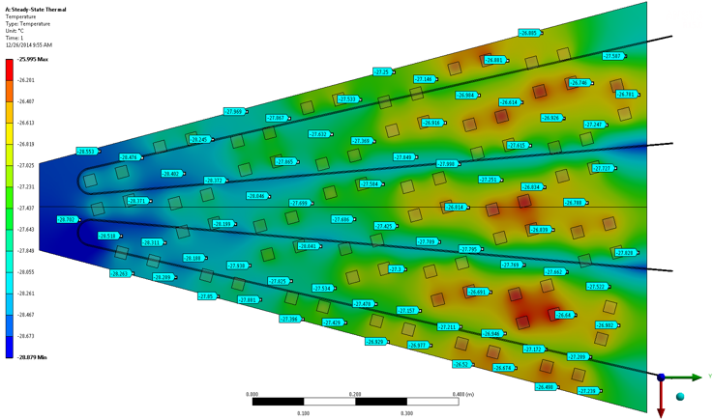As reported earlier we are conducting tests of the thermal modelling of CO2 cooling with mock-ups consisting of copper plates equipped with heaters and RTDs to measure the temperature across the plate.

Figure 10: Map of the predicted (color map) and the measured temperatures (data points) of a cassette-sized 3mm copper plate. Heaters (square pads) delivering 200 W to the plate were operational during these tests.

Tests of the first model were conducted in August 2014 and the results reported to the HGC group in early September.

A second thermal model was been made, like the first, at Minnesota and tested at with the CO2 cooling plant at FNAL. This plate had the same dimensions as the cassettes will have in HGC. It was 3 mm thick and equipped with two small-diameter copper pipes. The CO2 coolant was passed, while heat was applied to the plate through calibrated resistors and the temperature tracked with RTDs. The purpose of this test was to compare the predictions of a thermal model of the heat transfer with measurements. In Fig. 1 a plot of the measured temperatures and the temperature predicted by the thermal model are shown. With very nice agreement between the two.

### Module Engineering Studies:

The UCSB group has continued to study the manufacture and production of the silicon sensor modules. A report of all their work presented by J. Incandela can be found at a recent HGC general meeting (<https://indico.cern.ch/event/367396/>).

One study that has been conducted at UCSB include a detailed thermal model of with the baseplate made with different materials. We have settled on a design, shown in Fig 11, with a plate made with 80% tungsten and 20% copper. This has a coefficient of thermal expansion (CTE) that is nicely matched the CTE of silicon. In a separate set of tests, where the silicon module was cooled to -40 oC the thermal stress on the silicon was measured and found to me well within the limits set for the current CMS tracker. In another the measurement of the temperature of the silicon, when a module is attached to a copper cooling plate at -30 oC and heaters to represent the ASICs are attached. It was found in this test that, even when the temperature of the heater is +3 oC, as we can expect in normal operation, the temperature of the silicon increases to -27 oC in the immediate vicinity of the heater.

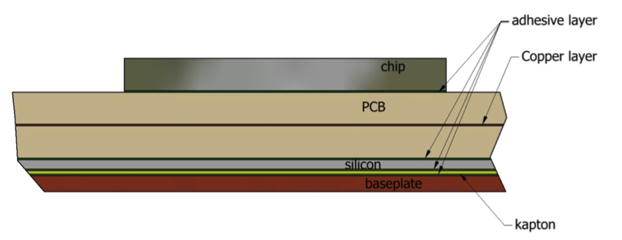

Figure 11 Schematic of detector module.

### Silicon Sensor irradiation studies.

Irradiation of *p-­*on-­*n* and *n-*on-*p* silicon diode detectors with depletion depths of 300µm, 200µm, and 125µm has been carried out at the Ljubljana reactor, to 1-MeV neutron equivalent doses of 1E16 have been carried out by the Hamburg group. US group member Shervin Nourbakhsh (Minnesota) made the systematic measurements of the diodes at DESY with members of the Hamburg group to characterize these diodes. The results were reported in an HGC general meeting <https://indico.cern.ch/event/343406/> the major result, reported at the December and January jamborees is that up to 1016 neutrons/cm2, the limit of the measurement and the maximum fluence expected, the 120µm diodes continue to operate with a reduced charge collection efficiency.



Figure 12. Results of the measurements of the charge collection efficiency (CCE) of heavily irradiated silicon pads. The 100 µm sensors have a CCE of ~50% of their initial value after irradiation.

### Other studies

A mechanical mock-up the detector was performed to demonstrate the feasibility of building cassettes with a gap of 2mm above the PCB. As part of this effort we are working with a manufacturer of large PCBs to make long power strips to bring the power and return to the modules form the edge of the detector. A full scale mockup was shipped to CERN in time for the December jamboree.

Paul Rubinov at Fermilab has performed an initial evaluation of the requirements for signal and power cables. He has made a preliminary design of the cable layout and the connector placement. A preliminary design was made of the FH mechanics by J. Tillman at FNAL.

## Outer Tracker

Here we report recent progress in dummy module fabrication, bump bonding, and 8” sensor R&D for the Phase 2 CMS outer tracker.

1. **Dummy module Fabrication**

Approximately 14,000 PS modules, which consist of two layers of silicon sensors separated by 2-5 mm will be needed for the phase 2 CMS tracker.

We are building thermally accurate “dummy” PS modules that will be used to thermally test the PS design, develop alternative techniques and materials, and begin understanding the assembly process. We have fabricated the following components to the CERN module design:

* Aluminum-carbon fiber frames
* Carbon fiber baseplates and cover pieces
* Kapton interconnect mockups
* Dummy sensors

We have also made initial thermal models of the assembly combined with a carbon fiber/carbon foam support rod which contains the CO2 cooling assembly. A conceptual drawing of the complete test structure is shown in Figure 1. The completed dummy module with heater and temperature sensor wiring is shown in Figure 13. Initial rounds of thermal test will be starting the week of Jan. 20.

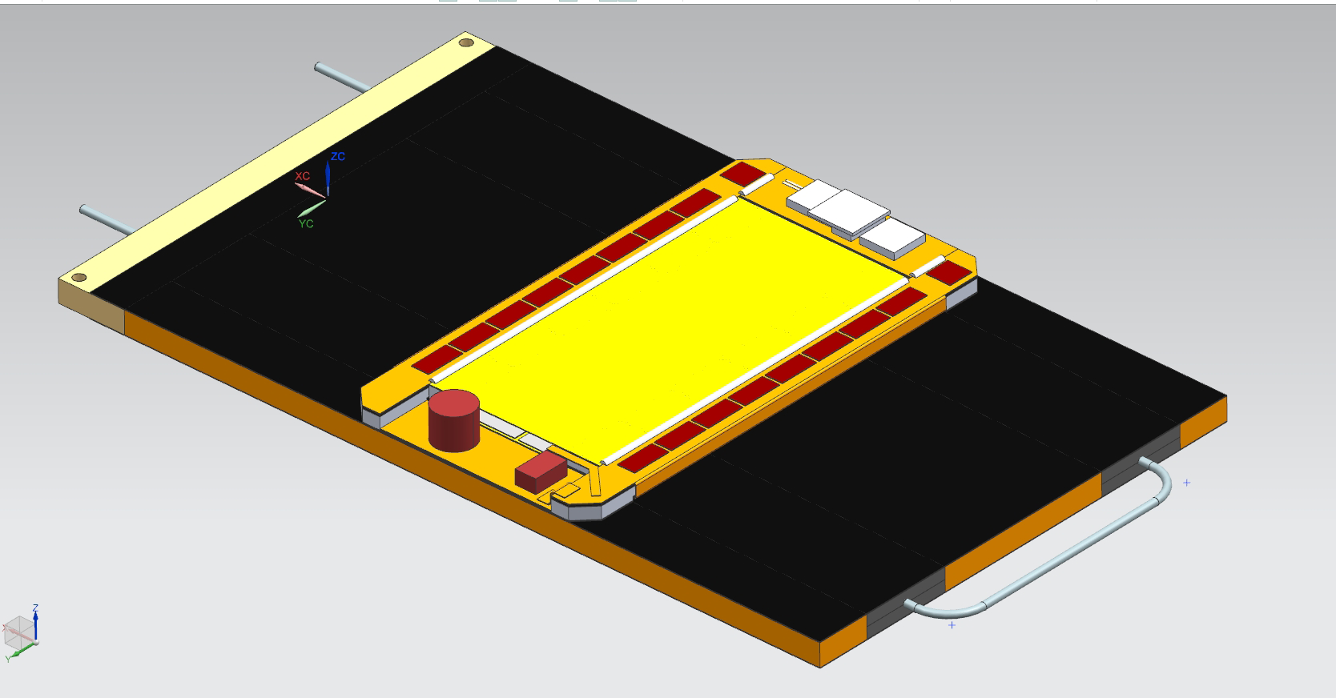

Figure 3. Drawing of a PS module assembled onto a carbon fiber/carbon foam support rod.

1. **Bump bonding**We have completed the designs for full-sized bump bonded dummy PS sensor and readout chip assemblies. These are now being fabricated at CVI Inc. The initial sensors fabricated and Cornell and UC Davis had issues related to metal thickness and top passivation that prevented successful bump bonding at the company. We decided to rely on CVI both for device fabrication and bonding in this round. We expect that following devices for testing MaPSA-lite (small versions of the PS module sensor and ROIC) will be fabricated at universities.

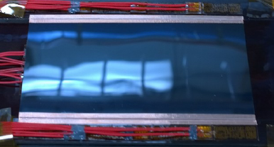

Figure 14. PS module thermal model with heaters and RTDs attached.

1. **8” Pilot Sensor Fabrication**  
   We have “taped-out” the design for the first high resistivity silicon sensor wafers to be fabricated on 8” silicon with Tezzaron/Novati (a US company). All previous wafers were based on 4” or 6” technology. This is an n-on-p DC coupled device with both full thickness wafers (725 microns) and wafers thinned to 500 microns. The layouts include CMS pixel, strip and High Granularity Calorimeter (HGC) designs as well as x-ray sensors from Argonne and ATLAS pixels from SLAC. Brookhaven provided the high resistivity p-type wafers and SLAC provided consultation on the process flow. Fermilab coordinated the overall design integration and provided test structure designs as well as the PS strip sensor layout. The overall layout is shown in Figure 15.  
     
   In addition to the sensor layout we worked with the manufacturer and SLAC to develop a process flow for the wafers that accommodates Novati capabilities and meets HEP requirements. The process was simulated using Silvaco TCAD design tools at Fermilab and the process steps validated. Crucial areas are the depth of the n implants, the density of the p-spray, and the density of the p-stop implants. These determine the interstrip resistance characteristics and the This allowed us to tailor the process to the needs of HEP.

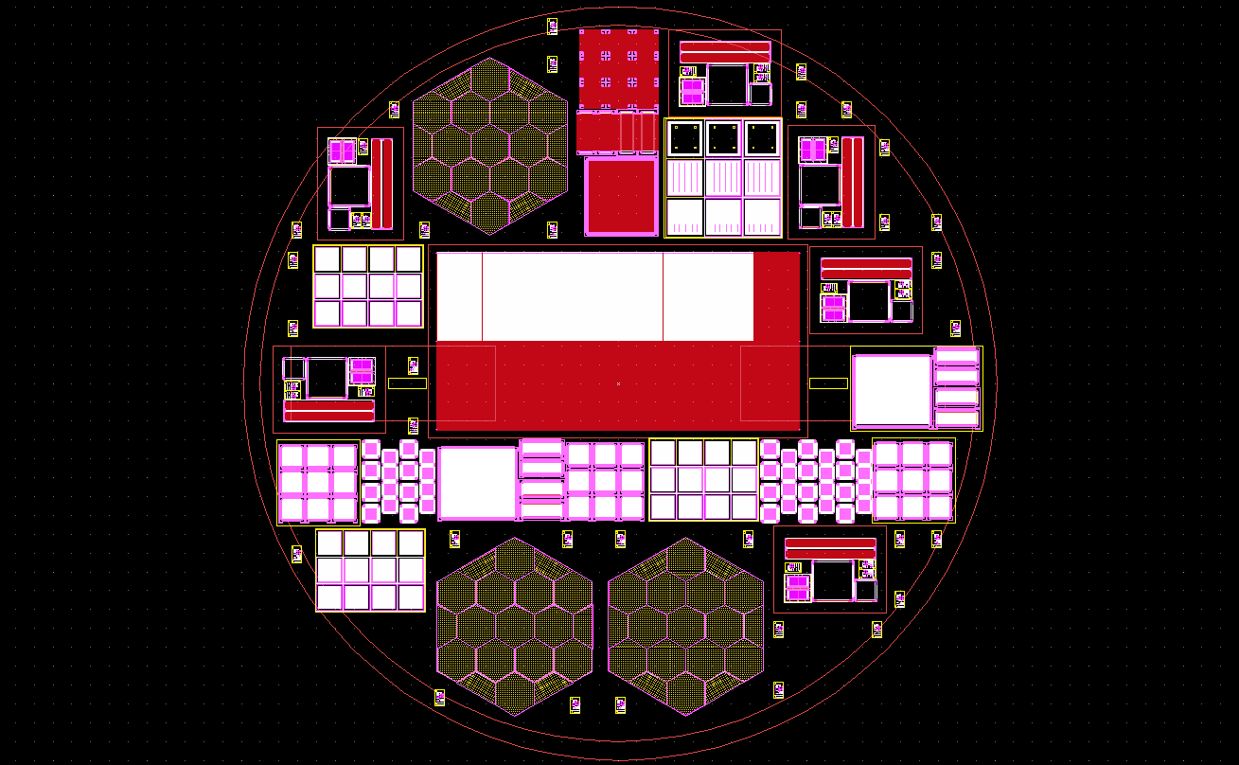

Figure 15. Tezzaron/Novati 8" sensor wafer layout.

Figure 16 shows the results of some of these simulations. Going clockwise from top left:

* A 10 micron deep section of the detector from an n strip edge past the p-stop showing the dense strip implant, more lightly doped p-spray, and the intermediate doping of the p-stop. Above the bulk silicon there is a passivation oxide with the aluminum contact metal outlined in black.
* An intermediate process step, after implantation, but before annealing. The greenish oxide rectangles define the implant openings. The magenta top photoresist blocks the p-stop opening while the strip is implanted.
* Strip implant profile after annealing. Depth is about 1.8 microns
* Strip implant profile before annealing. Depth is about 1 micron
* P-stop implant profile. Peak dose is about 4x1017
* P-spray implant profile. Peak dose is about 3x1015



Figure 16. Process simulation for Tezzaron/Novati wafers.